Fertility Indicators http://www.naturalfamilyplanning.ie/what-is-cervical-mucus/

^Ovulation Indicators

Cervical Mucus

* Typically: 90-95% water content
* Ovulation: 98-99% water content
* The other percentages are salts, organics, sugars, mucin etc – measuring these could be easier to measure
* Cervical MUCIN is very important. Accounts for most of the properties
* Gestogenic mucus is progesterone stimulated, infertile, moist/dam/ tacky, scant, opaque,viscous
* Oestrogenic under estrogen stimulation, mixes three subtates Loaf,String(sperm carrier),Peak and they are in the fertile cycle, sensation/appearance different for each. Wet slippery, raw egg white stretchy runny clear abundant

Most important for tracking is the build-up as the actual appearance/ chemistry can change between cycles.

Temperature:

* thermal shift indicates ovulation has happened
* after this ‘definitely infertile phase’
* progesterone causes this
* taken at the same time each day
* disturbed by fever/alcohol/sleep/stress/ etc.
* we need to fix those

Cervical Position

* fertile cervix moves higher up, difficult to reach, becomes soft and the’os’ (opening) will open wider --- picture feature :P or is that too hard ?

Hormones

* surge of lutenizing hormone(end of phase) – progesterone
* estrogen-3-glucoronide (rise at start of fertility)
* Follicular stimulating hormone-beginning of cycle

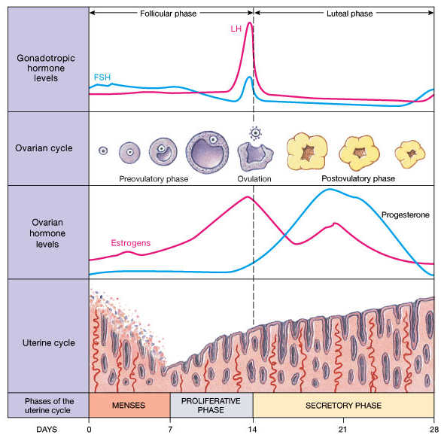

Predicting period

-Luteal length remains the same generally in all cycles